PROCESS
- A process is an instance of a computer program that is being executed.
- A program becomes a process when an executable file is loaded into memory.
- Operating systems have many background tasks running, your computer is likely to have many more processes running than actual programs.

PROCESS (CONT.)
- For example;
You may only have three programs running, but there may be twenty active processes.
You can view active processes in Windows by opening the Task Manager (press Ctrl-Alt-Delete and click Task Manager).

PASSIVE ENTITY & ACTIVE ENTITY
- File containing list of instructions stored on disk (often called executable file) called passive entity.
- A process is an active entity, with a program counter specifying the next instruction to execute and a set of resources.

A PROCESS GENERALLY INCLUDES
1. Process Stack
Process stack contain temporary data (such as function parameters, return addresses and local variables)
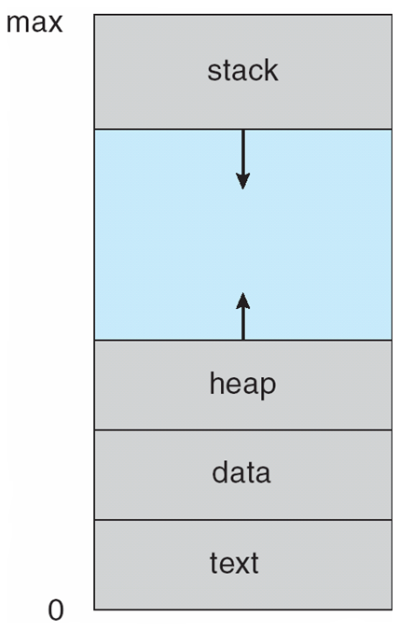
2. Data Section PROCESS IN MEMORY
Data section contains global variables.
3. Heap
Heap is a memory that is dynamically allocated during process run time.
4. Text Section
Contains program code.

PROCESS STATES
As a process executes, it changes state. Each process may be in one of the following states.
- New
The process is being created.
- Running
Instructions are being executed.
- Waiting
The process is waiting for some event to occur( such as an I/O completion or reception of a signal).
- Ready
The process is waiting to be assigned to a processor.
- Terminated
The process has finished execution.

PROCESS STATES DIAGRAM
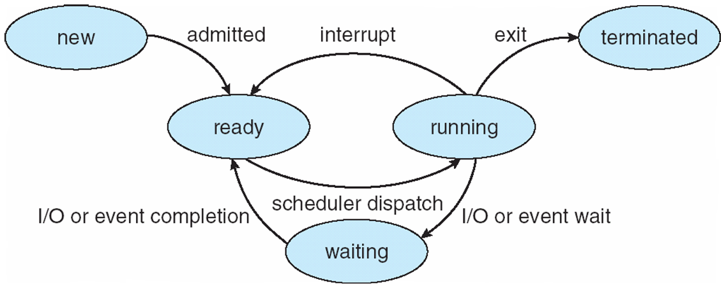

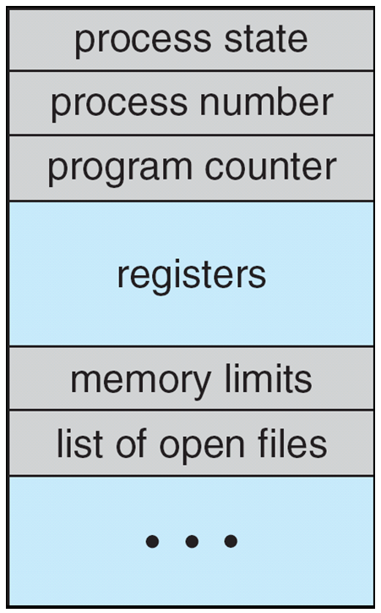
Process Control Block (PCB)
Each process is represented
in Operating System by a
Process Control Block(PCB).
- It is also called a task control block

Process state
- The state may be new, ready, running,waiting and so on.
Program counter
- Program counter indicate the address of the next instruction to be executed for this process.

CPU registers
The registers vary in number and type, depending on the computer architecture.They include:
- Accumulators(i.e an accumulator is a register in which intermediate arithmetic and logic results are stored).
- Index registers(i.e index register used for modifying operand addresses during the run of a program).
- Stack pointers(The stack pointer is used to give the address of the stack area,where the local variables and parameters to subroutines are stored).
- General purpose registers( i.e general purpose register is a small amount of storage available on the CPU whose contents can be accesses more quickly than storage available elsewhere).
- CPU-scheduling information
This information includes process priority, pointers to scheduling queues, and any ther scheduling parmeters.
- Memory-management information
This include value of the base and limit registers, the page tables, or the segment tables.
- Accounting information
This information includes the amount of CPU and real time used, time limits, account numbers, job or process numbers and so on.
- I/O status information
This includes the list of I/O devices allocated to the process, a list of open files and so on.

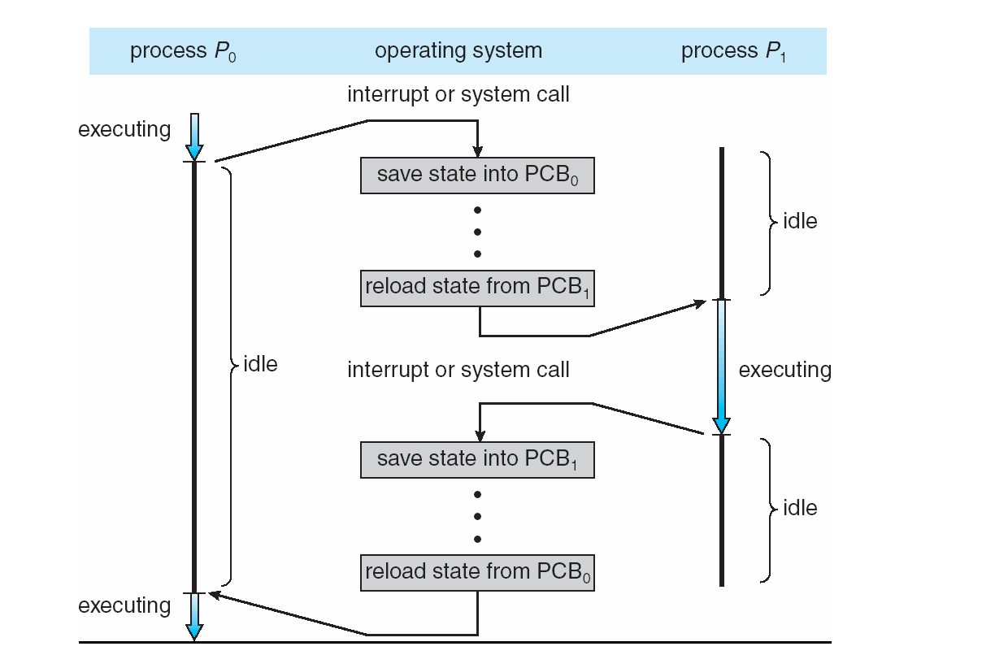
CPU Switch From Process to Process

Time Sharing
The objective of time sharing is to Switch the CPU among processes so frequently that users can interact with each program while it is running.
Process Scheduler & Process Identifier
- Process Scheduler: The purpose of process scheduler is to selects an available process (possibly from a set of several processes) for program executing on the CPU.
- Process Identifier (pid): Process identifier is used to uniquely identify a process.

OPERATIONS ON PROCESSES
There are two main operations that are applied on process.
1. Process Creation
2. Process Termination

PROCESS CREATION
A process may create several new processes, via a create- process system call, during the course of execution.

Parent Process: The creating process is called parent process.
Child process: The new process is called the children of that process.
Each of these new process may inturn create other processes, which forming a tree of processes.

PROCESS TERMINATION
A process terminate when it finishes executing its final statement and ask the operating system to delete it by using the exit() system call.

THREE MAJOR ACTIVITIES OF AN OPERATING SYSTEM IN REGARD TO MEMORY MANAGEMENT
Operating System has following three major activities in regard to memory management.
- Keep track of which part of memory are currently being used and by whom.
- Decides which processes are to be loaded into memory when memory space becomes available.
- Allocate and de-allocate memory space as needed.
Operating System has following three major activities in regard to secondary storage management
- Free space management
- Storage management
- Disk Scheduling

SCHEDULING QUEUES
As processes enter the system, they are put into a job queue, which consists of all processes in the system.
- Ready Queue
The processes that are residing in main memory and are ready and waiting to execute are kept on a list called the ready queue.

- Device Queue
Suppose the process makes an I/O request to a shared device , such as printer. Since there are many processes in the system, the printer may be busy with the input/output request of some other process. The process may have to wait for the printer. This list of processes waiting for a particular I/O device is called device queue.
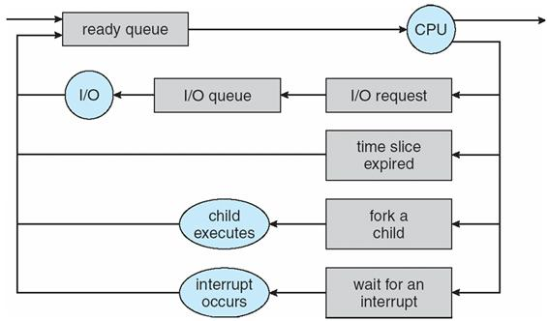

WHICH EVENTS COULD OCCUR WHEN A PROCESS IS ALLOCATED THE CPU AND IS EXECUTING
When a process is executing , then following events can occurs.
- The process could issue an I/O request and then be placed in an I/O queue.
- The process could create a new sub-process and wait for the sub-process’s termination.
- The process could be removed by force from the CPU, as a result of an interrupt, and be put back in the ready queue.
SCHEDULERS
There are three types of schedulers in Operating System
- Long Term Scheduler (or job scheduler)
selects which processes should be brought into the ready queue. New state to ready state.
- Short Term Scheduler (or CPU Scheduler)
selects which process should be executed next and allocates CPU. Ready state to running state.
- Medium Term Scheduler (or swapper)
responsible for suspending and resuming the processes. Main memory to Secondary memory.
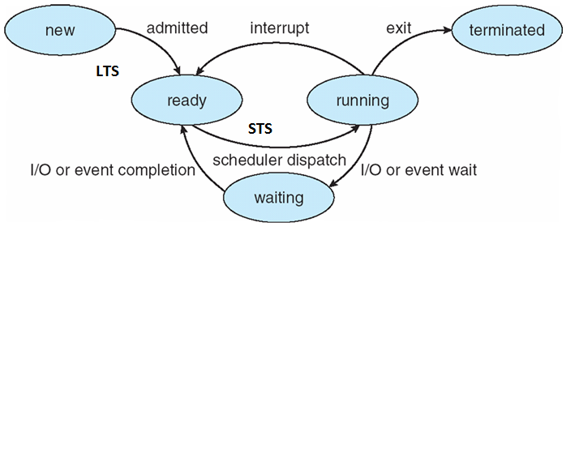
Process State Diagram

Degree of Multiprogramming
- The no. of processes present in the main memory at any point of time is called degree of multiprogramming.
- Long Term Scheduler controls the degree of multiprogramming.
- LTS should select the good combination of CPU bound and I/O bound Process in order to get good throughput.
- If more CPU bound Process then CPU utilization more and throughput low.

I/O-bound process : Spends more time doing I/O than computations, short CPU bursts
CPU-bound process : Spends more time doing computations; very long CPU bursts
CPU Burst : a time period during which the process wants to continuously run in CPU.
Cooperating Processes
- Processes within a system may be independent or cooperating
  - Independent process cannot affect (or be affected) by the execution of another process
  - Cooperating process can affect (or be affected) by the execution of another process
- Advantages of process cooperation
  - Information sharing
  - Computation speed-up
  - Modularity (application will divided into modules/sub tasks)
  - Convenience (may be better to work with multiple processes)

Inter Process Communication(IPC) Mechanisms
- Cooperating process require a facility/mechanism for interprocess communication(IPC)
- There are two basic mechanism provided by most systems
1. Shared Memory
2. Message Passing

Shared Memory IPC Mechanism
- A region of shared memory is established between (among) two or more processes
- Establisment of that shared region is done via the help of the operating system kernel
- Then, processes can read and write shared memory region (segment) directly as ordinary memory access (like they are accessing memory variables directly without kernel help)
Shared Memory IPC Mechanism
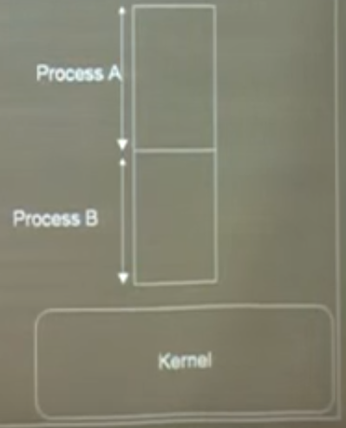
- To illustrate the use of the shared memory IPC mechanism, a general model problem, called producer-consumer problem, can be used.
- Producer-consumer problem
we have a producer, a consumer and data is sent from producer to consumer.
  - unbounded-buffer places no practical limits on the size of the buffer
  - Bounded-buffer assumes that there is fixed buffer size
Producer-Consumer Problem
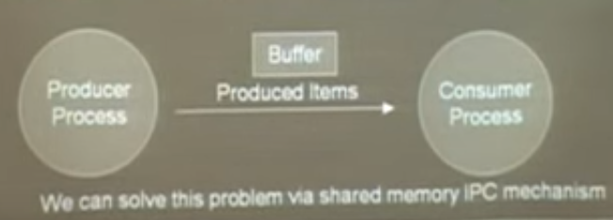

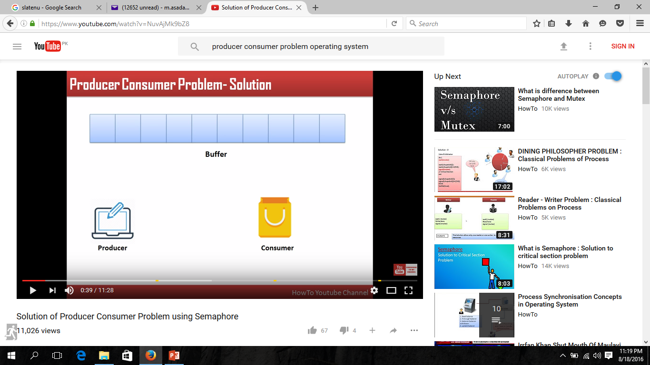

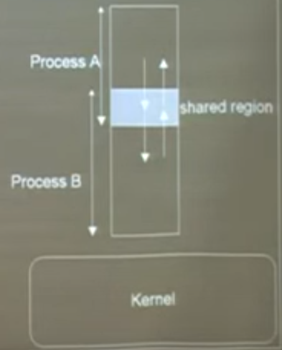

Message Passing IPC Mechanism
- Mechanism for processes to communicate and synchronize their actions
- This IPC facility provides two operations:
  - Send (message)- message size fixed or variable
  - Receive (message)

- If P and Q wish to communicate, they need to:
  - establish a (logical ) communication link between them.
  - Exchange messages via send/receive
Direct Communication
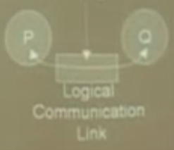
- Each process wanting to communicate must explicitly name the recipient or sender of communication.
  - send (destinatination-process P, message) – send a message to process P
  - receive(source-process Q, message) – receive a message from process Q
  - Properties of a direct communication link
  - Links are established automatically
  - Link is associated with exactly one pair of communicating processes
  - Between each pair there exists exactly one link
  - The link may be unidirectional, but is usually bi-directional
Indirect Communication
- Messages are directed and received from mailboxes
  - Each mailbox has a unique id
  - Processes can communicate only if they share a mailbox
  - Properties of an indirect communication link
  - Link established only if processes share a common mailbox
  - A link may be associated with many processes
  - Each pair of processes may share several communication links
  - Link may be unidirectional or bi-directional
- Operations
  - create a new mailbox
  - send and receive messages through mailbox
  - delete a mailbox
  - Primitives are defined as:
send(A, message) – send a message to mailbox A
receive(A, message) – receive a message from mailbox A

Synchronization
- Message passing may be either
  - Blocking, or
  - Non-blocking
- Blocking is considered synchronous(occuring at same time)
  - Blocking send -- the sender is blocked until receiving process does a corresponding read
  - Blocking receive -- the receiver is blocked until a message is sent for it to receive
- Non-blocking is considered asynchronous(not occuring at same time)
  - Non-blocking send -- the sender sends the message and continues
  - Non-blocking receive -- the receiver receives:
    - A valid message, or
    - Null message
Buffering in Message-Passing
- Messages exchange by communicating processes reside in a temporary queue.
- Queue implemented in one of three ways
  - Zero capacity – queue length 0
No messages wait. Sender must wait until receiver receive the message
  - Bounded capacity – finite length queue
Messages can be queued as long as queue not full, otherwise sender has to wait if queue full
  - Unbounded capacity – infinite length
Any number of messages can be queued ,sender never waits

Threads
- A thread is a light weight process.
- A thread is a basic unit of CPU utilization, it comprises ;
  - Thread ID
  - Program counter
  - Register set
  - Stack
Single Threaded and Multi Threaded Process
- Many software packages that run on modern desktop PCs are multithreaded. An application typically is implemented as a separate process with several threads of control.
- For example, a word processor ;
  - A thread for displaying graphics.
  - Another thread for responding to keystrokes from the user.
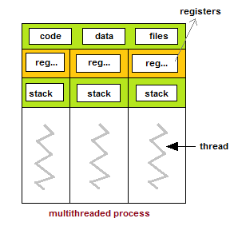
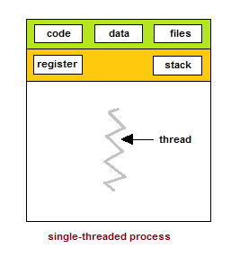
  - And third thread for performing spelling and grammar checking in the background.

Benefits of Multithreaded Programming
- There are five major benefits of multithreaded programming.
  - Responsiveness.
  - Resource sharing
  - Economy
  - Scalability
  - Less communication overheads
Responsiveness
- Multithreading increase the responsiveness to the user. Multithreading may allow a program to continue running even if part of it is blocked or is performing a lengthy operation.
- For instance, a multithreaded web browser could allow user interaction in one thread while an image was being loaded in another thread.
Resource Sharing
- Threads share the memory and the resources of the process to which they belong by default.
- The benefit of sharing code and data is that it allows an application to have several different threads of activity within the same address space.
Economy
- Allocating memory and resources for process creation is costly.
- Thread share the resources of the process to which they belong, so it is more economical to create thread.
- It is much more time consuming to create and manage process than thread.
- For e.g Solaris, creating a process is about thirty times slower than is creating a thread.
Scalability
- The benefits of multithreading can be greatly increased in a multiprocessor architecture, where threads may be running in parallel on different processors.
- A single threaded process can only run on one processor, regardless how many are available.
Less Communication Overheads
- Communicating between the threads of one process is simple because the threads share everything, address space.
- So, data produced by one thread is immediately available to all the other threads.
Single Core and Multi Core System
- A recent trend in system design has been to place multiple computing cores on a single chip, where each core appears as a separate processor to the operating system.
- Multithreaded programming provides the mechanism for more efficient use of multi-cores and improved concurrency.

Thread Execution on Single Core System
- Consider an application with four threads
(T1, T2, T3 and T4). On a system with a single computing core, concurrency merely means that the execution of a threads will be interleaved over time, as the processing core is capable of executing only one thread at a time. As shown in figure below;
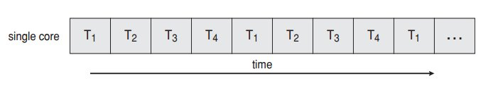

Thread Execution on Single Multiple Core System
- On a system with multiple cores, however , concurrency means that the thread can run in parallel, as the system can assign a separate thread to each core.
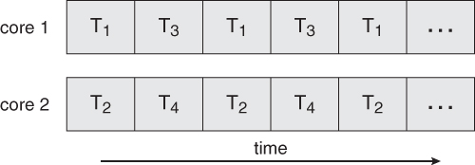

Thread Library
- A thread library provides the programmer with an Application programming interface (API) for creating and managing threads.
- Thread library contain code for;
  - Creating and destroying threads.
  - Passing messages and data between threads
  - Scheduling thread executing
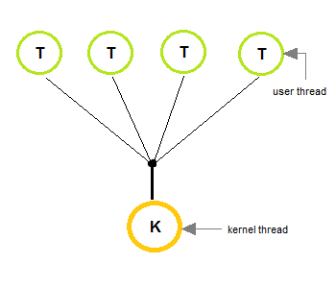
  - Saving and restoring thread contexts

Kernel Threads
- Kernel threads exist within the context of a process and provide the operating system the means to address and execute smaller segments of the process.
- It also enables programs to take advantage of capabilities provided by the hardware for concurrent and parallel processing.
- Kernel threads are supported and managed directly by the operating system.

Multithreading Models
(Many-To-One Model)
- In many-to-one model, many user level threads are map to one kernel thread.
- Thread management is done by the thread library in user space.
- This model is efficient , but the entire process will block if a thread makes a blocking system call.
- Only one thread can access the kernel at a time, multiple threads are unable to run in parallel on multiprocessors.
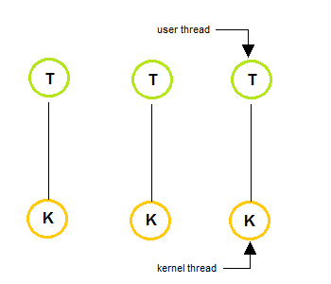
Multithreading Models (One-To-One Model)
- In one-to-one model, each user thread map to kernel thread.
- It provides more concurrency than many-to-one model by allowing another thread to run when a thread makes a blocking system call.
- This model allows running multiple threads on multiprocessor system.

Multithreading Models (Many-To-Many Model)
- The many-to-many multiplexes many user level threads to a smaller or equal number of kernel threads.
- In many-to-many model, when a thread performs a blocking system call, the kernel can schedule another thread for execution.
